 | Learner Resource
Assessment within adult social care

Version 1.4 October 2024

Contents
Advocacy 1
Types of advocate 1
Assessment -----------------------------------------------------------------------------------------------------------------------2
Types and process--------------------------------------------------------------------------------------------------------------- 3
Wellbeing -----------------------------------------------------------------------------------------------------4
What is meant by wellbeing -------------------------------------------------------------------------------4
Preparing for an assessment-------------------------------------------------------------------------------4
What does 'good ' look like?------------------------------------------------------------------------------ 5
Strengths-based approach ------------------------------------------------------------------------------- -5
Practice tools ------------------------------------------------------------------------------------------6
Practice tools-------------------------------------------------------------------------------------------------7
Practice tools ------------------------------------------------------------------------------------------------8
Risk ------------------------------------------------------------------------------------------------------------9
Communication --------------------------------------------------------------------------------------------10
Paraphrasing-------------------------------------------------------------------------------------------------11
Capturing the voice----------------------------------------------------------------------------------------12
Accurate recording----------------------------------------------------------------------------------------13
Models for change-----------------------------------------------------------------------------------------14
Resources----------------------------------------------------------------------------------------------------15

Advocacy

Types of advocates

 | What is advocacy?  “Advocacy is taking action to help people say what they want, secure their rights, represent their interests and obtain services they need. Advocacy promotes social inclusion, equality and social justice. “  (The Advocacy Charter, 2018).  Care Act Advocacy  Supports with accessing information, understand options/rights, to prepare for and take part in assessments/meetings, supports with decision making.  Independent Mental Health Advocacy (IMHA)  Advocates who have had specialist training around the Mental Health Act 1983.  Deprivation of Liberty Safeguards (DoLS)  In a hospital or care home and lack the capacity to consent to their care and support arrangements and are subject to continuous supervision and control and is not free to leave.  Relevant Person’s Representative (RPR)  Every person who is subject to a DoL has an RPR, usually a friend or family member.  Independent Mental Capacity Advocate (IMCA)  A safeguard for people who lack capacity and who don’t have anyone who isn’t paid to be in their life to support them.

Assessment

Types of assessment
Activity

What different types of assessment can you think of?

---------------------------------------------------------------------------------------

---------------------------------------------------------------------------------------

---------------------------------------------------------------------------------------

---------------------------------------------------------------------------------------

--------------------------------------------------------------------------------------
Information

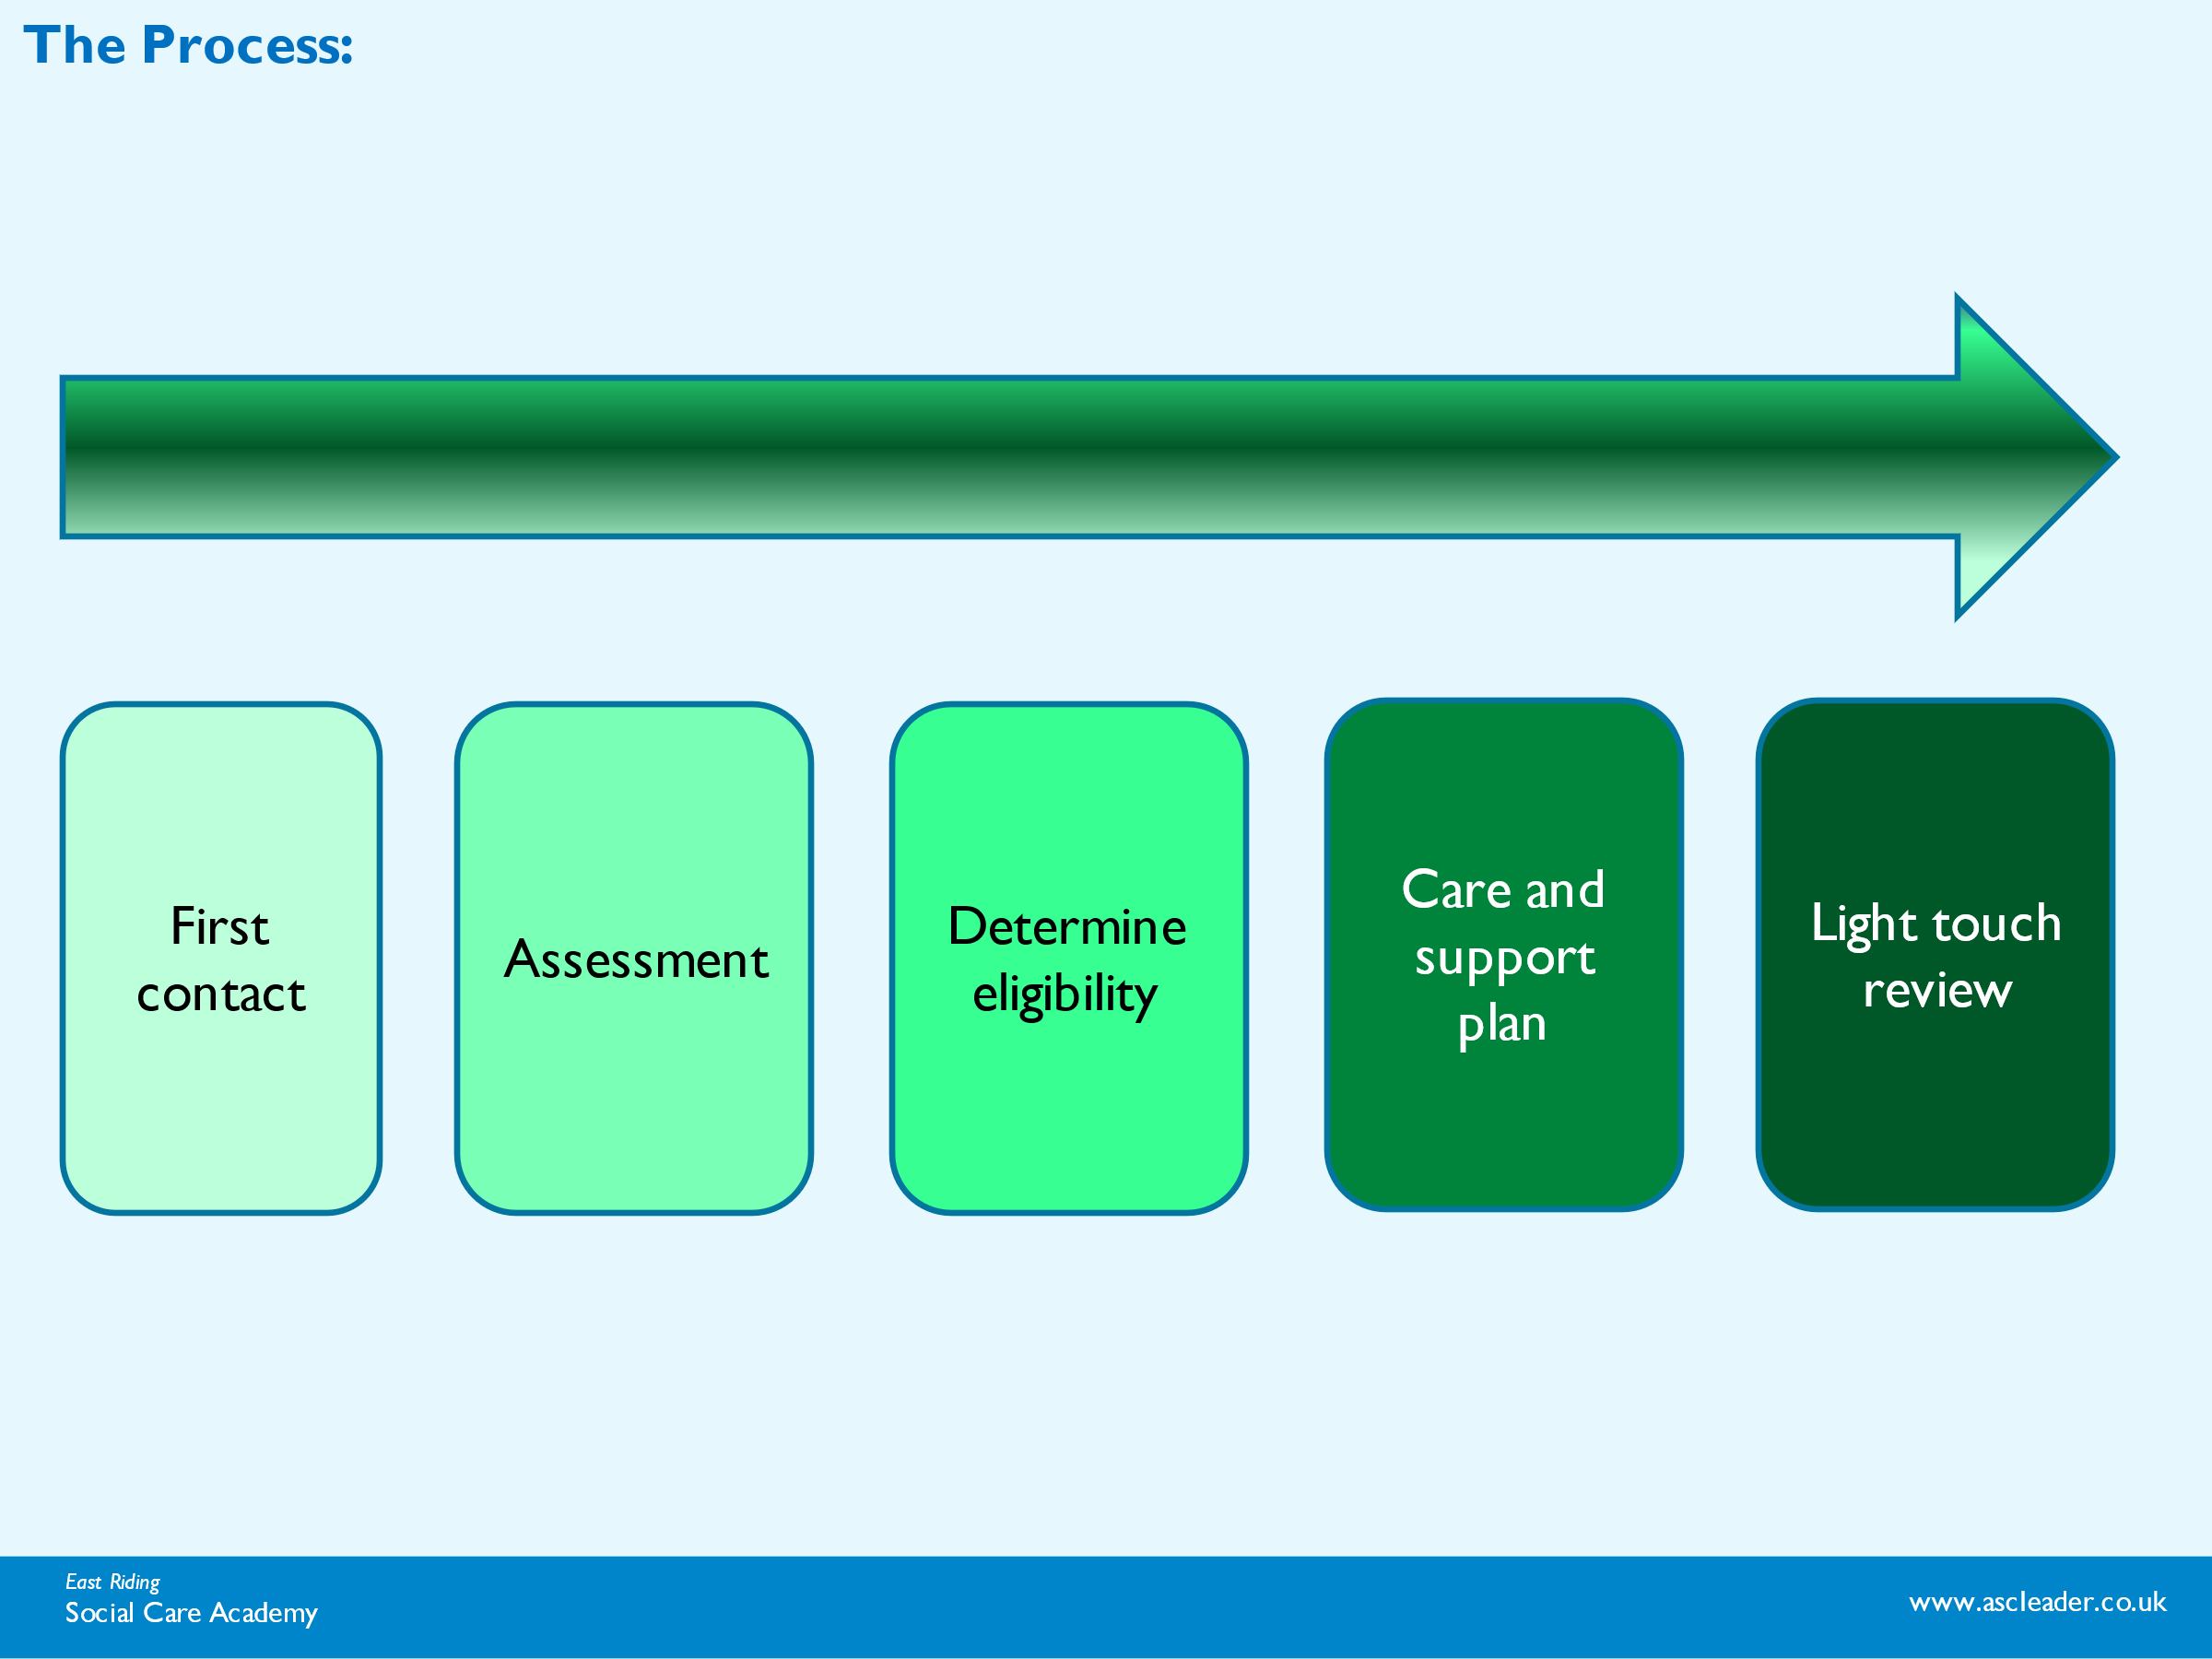

Outcomes

Personal outcomes
   | Information  Remember: Personal outcomes are not services, resources, interventions, or steps taken to achieve an outcome-  Mr A is a 91 year old man who lives alone with his dog in his house. He is usually independent, is a passionate cook and enjoys socialising. He drives a car. Whilst out walking his dog he suffered a stroke, he fell, causing a fractured hip. He was admitted to hospital and underwent surgery for a hip replacement which meant he had to follow hip precautions for 6 weeks.  The stroke had left him with slight left-sided weakness and problems with concentration, sequencing and attention. He was transferred to a community hospital for rehabilitation where the physiotherapists (PTs) and occupational therapists (OTs) worked on mobility, transfers, personal care following hip precautions, stair climbing and kitchen tasks. Cognitive screens were completed and the OTs targeted their input on helping improve concentration, sequencing and attention. Mr A wanted to continue to live independently at home. Mr A was discharged, independently mobile using a frame, independent transferring using equipment and stair climbing with supervision. He was discharged home with 4 calls per day from BEST plus (Bradford Enablement Support Team.  Activity 1 page 3: Using the case study taken from the care and Support Statuary guidance https://www.gov.uk/government/publications/care-act-statutory-guidance/care-and-support-statutory-guidance please complete the activity in the learner resource, create 3 more outcomes for Mr A, and then identify the steps taken and service interventions or provisions required to achieve the outcome.  Personal outcome Steps taken Service, interventions or provisions to achieve the outcome  To be safe and independent walking outdoors using 2 sticks Exercises to increase hip strength. Walking indoors using sticks. 4 wheeled walker supplied. 2 sticks supplied

Wellbeing
What is meant by wellbeing?
Activity:
What is meant by wellbeing-?

What Is important to your own wellbeing?

Preparing for an assessment
When does it start?
Activity:
When does an assessment start?

Discuss how to prepare for an assessment or key interaction.

What do you need to know?
What do you need to think about?

----------------------------------------------------------------------------------------

What does ‘good’ look like?
Activity:

What do you think makes a good assessment or interaction?

Strengths-based approach

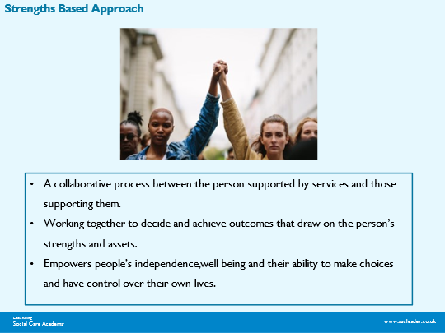

Practice Tools
Helen Sanderson

http://helensandersonassociates.co.uk/about/how-can-we-help-you/our-courses/person-centred-thinking

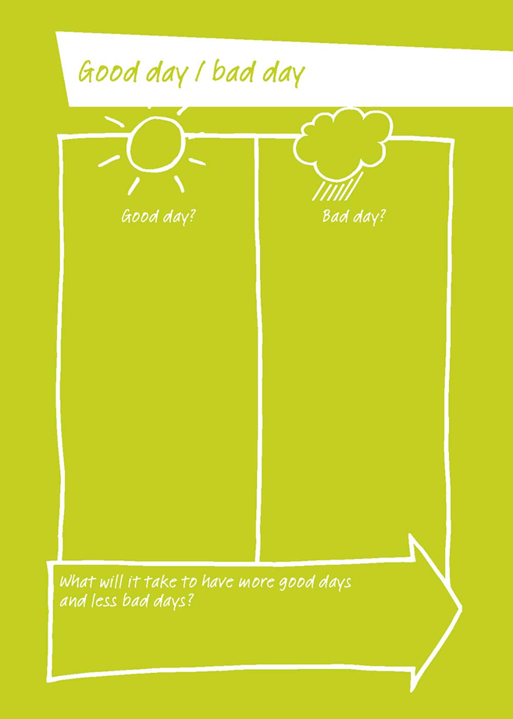

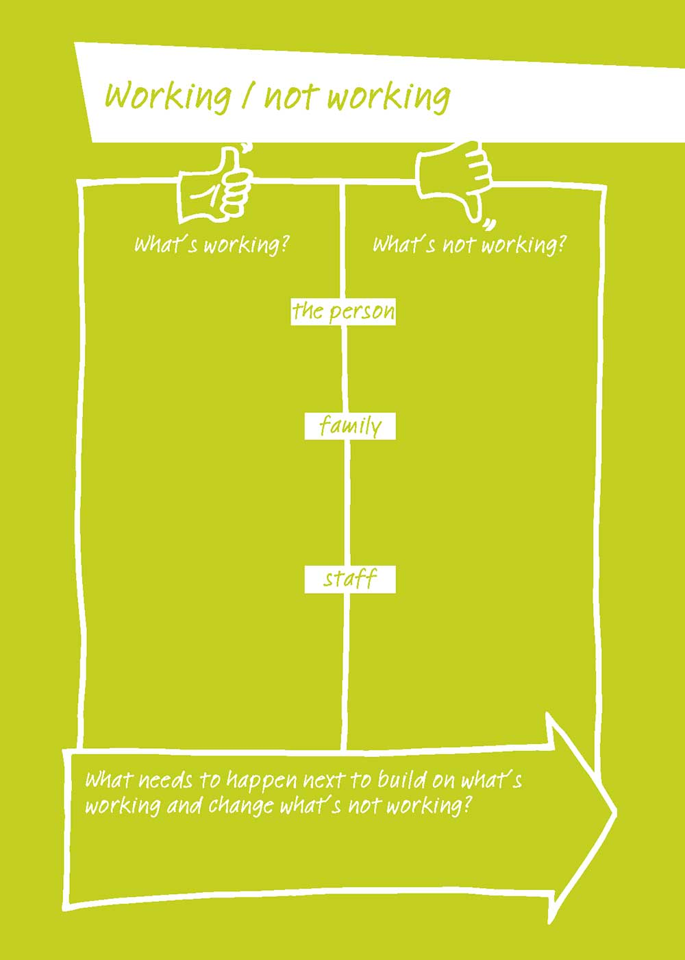

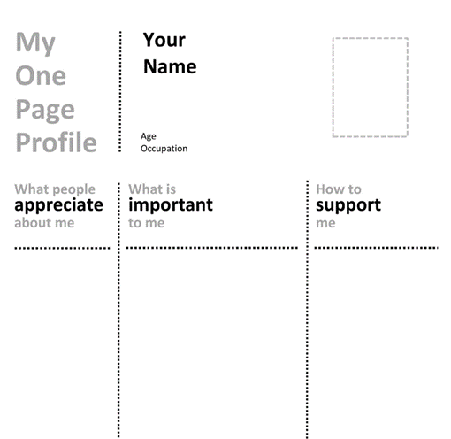

https://helensandersonassociates.com/person-centered-thinking-tools/

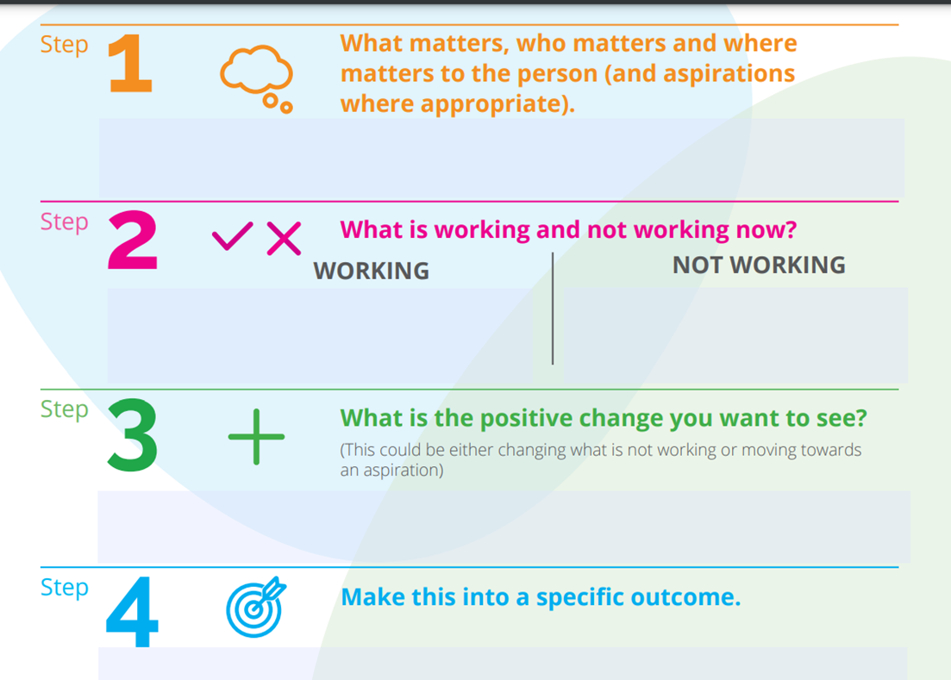

https://www.helensandersonassociates.com/hsa-around-the-world/united-kingdom/outcome-and-support-sequence-resources

Risk Activity
 | 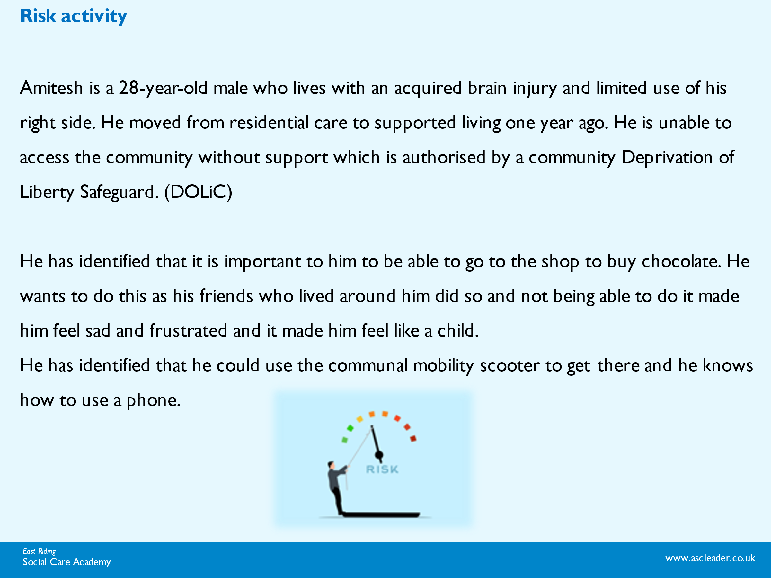  Using the case study on the slide ( or one of your own choice) from SCIE answer the benefits and harms for the 2 options.  Option1 Action to mitigate Goes with support (mum or support worker) Option 2 Action to mitigate Goes alone with mobile phone  Impact/Benefits: Impact/Benefits  Harms Harms  Steps Steps  Outcomes Outcomes

Positive behaviour Support
 | https://www.bild.org.uk/wp-content/uploads/2022/06/Good_PBS_POB_SCREEN.pdf

Communication
Accessible Information Standards

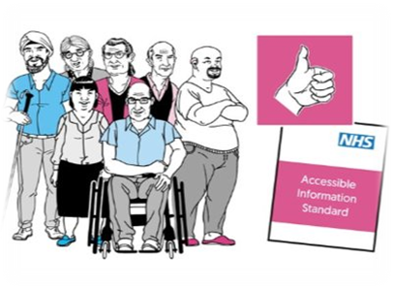
More info https://www.england.nhs.uk/about/equality/equality-hub/patient-equalities-programme/equality-frameworks-and-information-standards/accessibleinfo/ )

Free guides (plainenglish.co.uk)
Think Local Act Personal (TLAP) Care and Support Jargon Buster is a directory of Plain English definitions of commonly used words and phrases in health and social care

Communication: Paraphrasing and Reflecting

 | Client (Mohammed): My ex-wife phoned me yesterday; she told me that our daughter Nadia (who is only 9) is very ill after a car accident. I am feeling very scared for her. They live in France, so I am going to have to travel to see her, and now I have been made redundant, I don’t know how I can afford to go.  Using the case note above, try paraphrasing it- what could you say to reflect it to the client?  In pairs learners to take turns telling each other ‘a story’ about their daily routine or describing a recent day they have had.  Start by listening.  Focus on feelings and thoughts.  Capture the essence of the message.  Offer a brief version of what has been said.  Please could you tell me about your day so far…

Capturing the voice of the individual

 | No decision about us…without us  Strengthening People’s Voices in Health and Adult Social Care  How can we make sure that we capture the voices of the people we support?  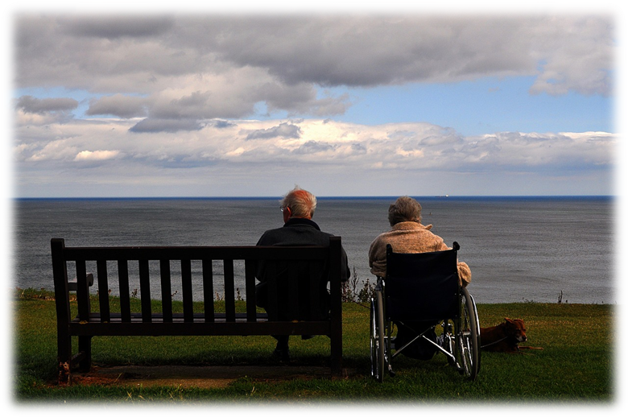
Accurate recording

Partnership model for accurate recording. Please complete

P---------------------------------------------------
A--------------------------------------------------
R---------------------------------------------------
T---------------------------------------------------
N--------------------------------------------------
E--------------------------------------------------
R--------------------------------------------------
S--------------------------------------------------
H-------------------------------------------------
I---------------------------------------------------
P------------------------------------------------------------

Case recording

 | Activity  ‘I visited Mrs X in her care home today and talked to her, to review her care needs. I was already seeing someone else there so thought I could pop to see her as well. She was a bit disorientated, seemed preoccupied and therefore I was not always sure what she was saying. I’m not sure if she has a hearing aid. I wasn’t able to speak to her daughter either as she was coming later in the day so I did manage to grab the senior care officer and we discussed Mrs X’s SALT visit and nutritional needs. After 40 minutes or so I decided to come back another day. Hopefully by then I’ll have had a chance to talk to her daughter. I was told that Mrs X does not request food or drinks herself and therefore needs full assistance from her carers. Generally, her diet is poor, and she requires supplements for extra calories intake. She was referred to SALT in January 2023 due to weight loss (3kg in a short time) Due to this she now has level 1 thickened fluid and level four pureed diet. She is on fluid and food monitoring charts to manage and maintain her nutrition but I was not able to see them as the digital system was down again. She is known to cough when drinking causing poor aspiration which means she is prone to choking and swallowing issues. She likes to eat yoghurt, soups, milk and orange juice and likes a glass of wine on an evening. They are waiting for an OT assessment. I left before lunch and said I would ring to arrange another visit. Mrs X didn’t reply.  In groups discuss this example and use the PARTNERSHIP model, can you please write a case note that is both accurate and demonstrates an affective recording of the information given. You may add in any details you think are missing such as dates, changing the language etc.  (If training is being held face to face, learners can use own examples if they have them)  -------------------------------------------------------------------------------

Models

Prochaska ad Di Clemente’s cycle of change

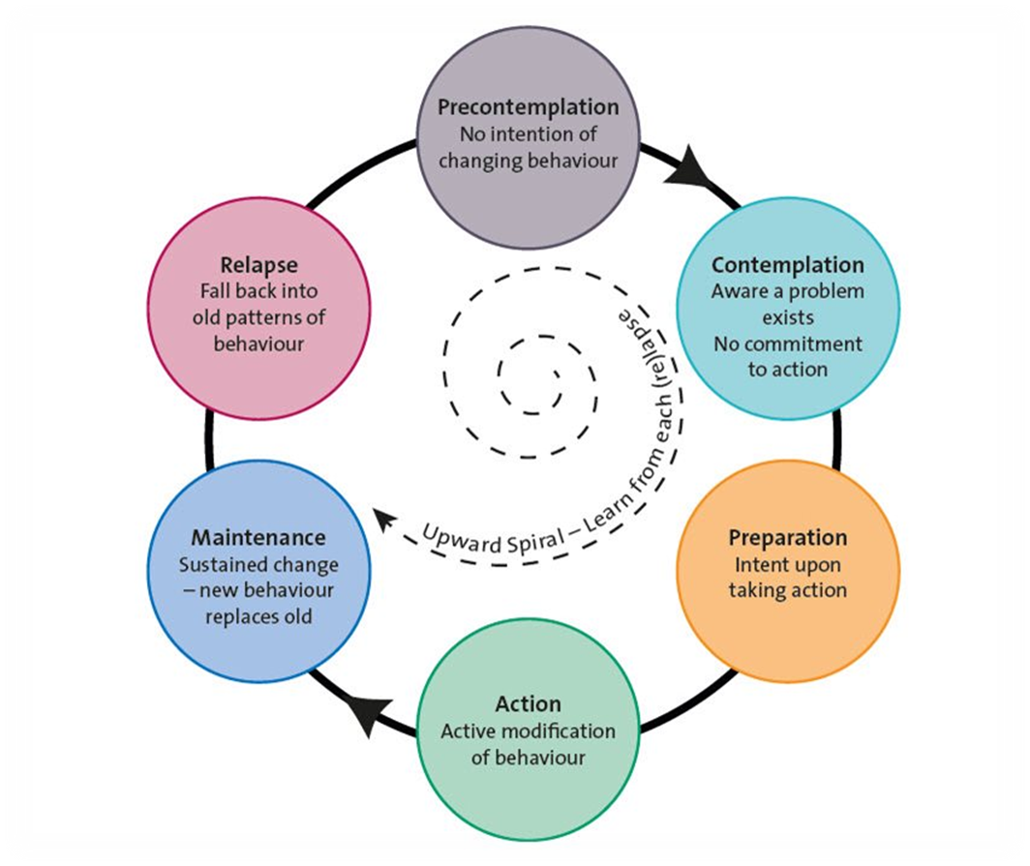

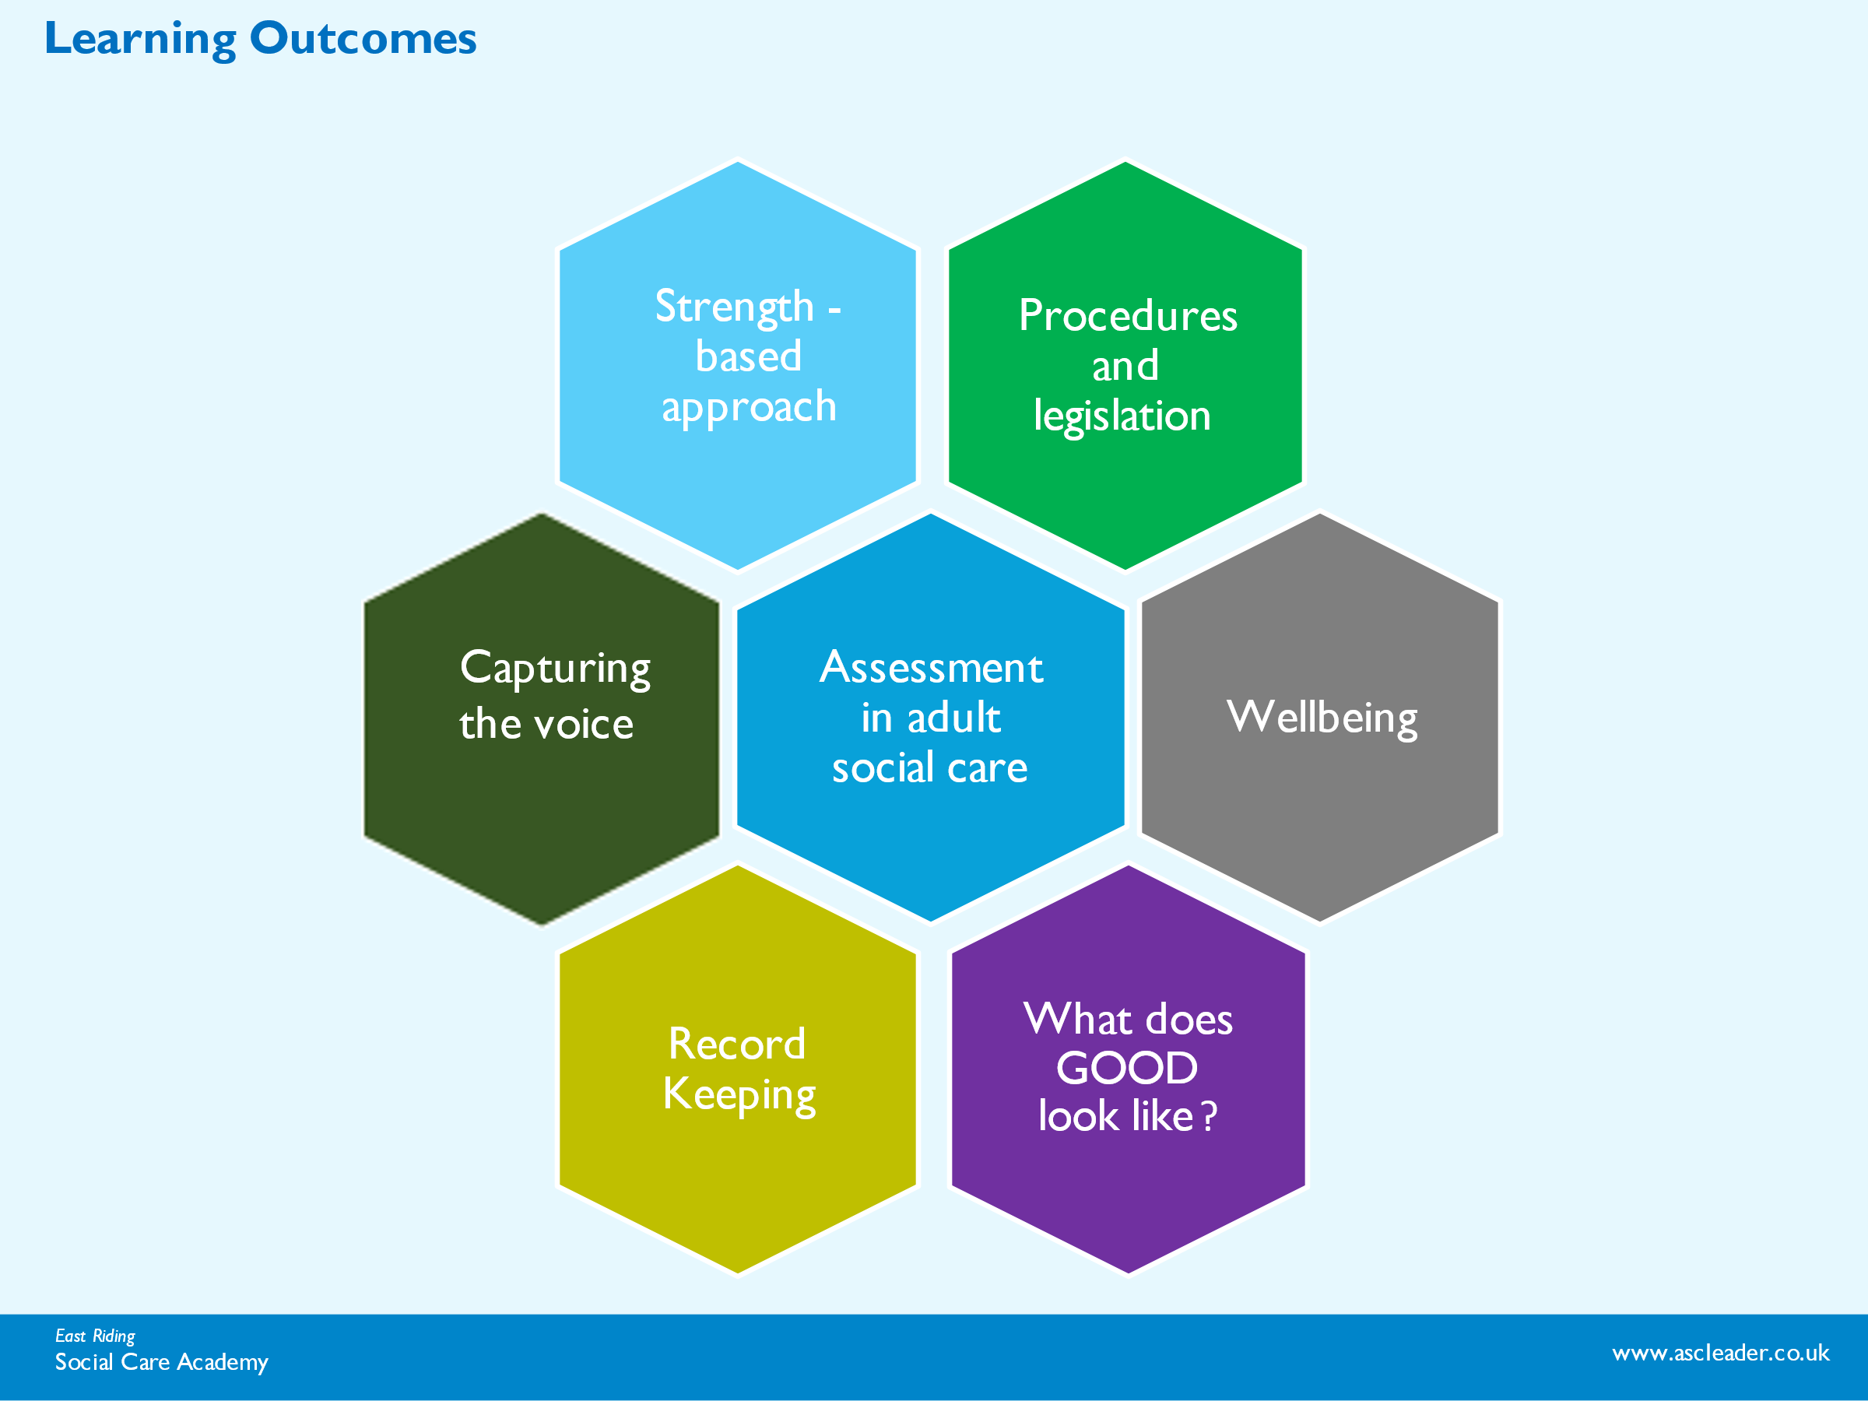

Resources and Links

https://www.voiceability.org/about-advocacy/types-of-advocacy/care-act-advocacy

Helen Sanderson - All about outcomes - Helen Sanderson Associates

http://www.gov.uk/government/publications/care-act-statutory-guidance/care-and-support-statutory-guidance

Jak Savage: Social care consultant and lived experience (SCIE

http://helensandersonassociates.co.uk/about/how-can-we-help-you/our-courses/person-centred-thinking/

https://www.helensandersonassociates.com/hsa-around-the-world/united-kingdom/outcome-and-support-sequence-resources

. http://helensandersonassociates.co.uk/person-centred-practice/maps/

https://www.thinklocalactpersonal.org.uk/_assets/Resources/Personalisation/Personalisation_advice/A_Person_Centred_Approach_to_Risk.pdf

https://www.bild.org.uk/wp-content/uploads/2022/06/Good_PBS_POB_SCREEN.pdf

More info https://www.england.nhs.uk/about/equality/equality-hub/patient-equalities-programme/equality-frameworks-and-information-standards/accessibleinfo/

http://www.helensandersonassociates.co.uk/wp-content/uploads/2015/01/careandsupportselfassessmenthandout.pdf

https://eryc.sharepoint.com/:b:/r/sites/ASCHQualityPracticeFramework/Shared%20Documents/General/PRACTITIONER%20FACTSHEETS/11-%20Factsheet%20Case%20Recording.pdf?csf=1&web=1&e=eQtt45

https://eryc.sharepoint.com/:b:/r/sites/ASCHQualityPracticeFramework/Shared%20Documents/General/PRACTITIONER%20FACTSHEETS/10-%20Factsheet%20Risk%20Assessment.pdf?csf=1&web=1&e=Fd8fz9

https://eryc.sharepoint.com/:b:/r/sites/ASCHQualityPracticeFramework/Shared%20Documents/General/PRACTITIONER%20FACTSHEETS/3-%20Factsheet%202%20Adult%20Care%20%26%20Support%20Assessment.pdf?csf=1&web=1&e=Ip13df

Fire safety online tool-
https://www.safelincs.co.uk/hfsc/

skillsforcare.org.uk/resources/documents/Developing-your-workforce/Care-topics/Culturally-appropriate-care/Culturally-appropriate-care-guide.pdf

